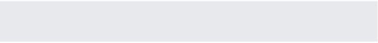
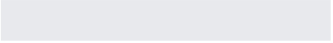
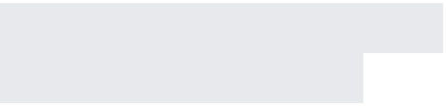
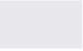
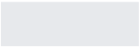
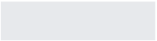
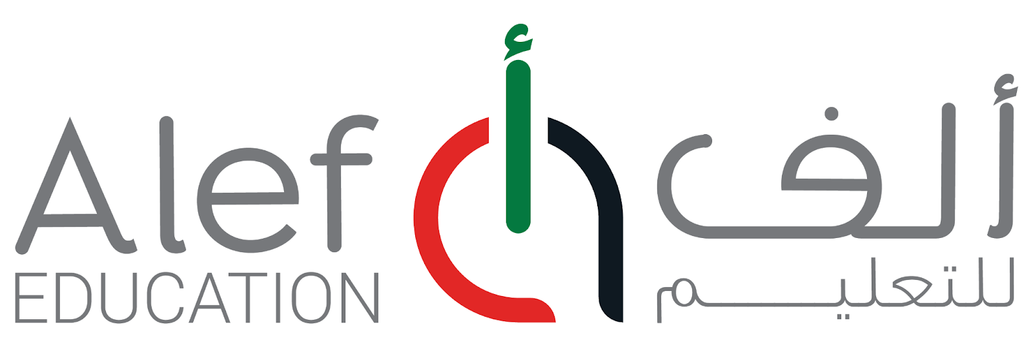
Request Form for Freelancer or Vendor User Access 1. Requestor Information
Requestor’s Name: | Shamma Almessabi | Role: | AMS Publishing Manager
Division: | Product Development | Team: | Arabic Medium Subjects Publishing Manager
Email Address: | shamma .almesaabi@alefeducation.com
Date of Submission: | Feb 13, 2026 | Priority: | High
2. Services Required - check the box(es)
Contractor Email | AAT - CCL  Word Bank | Wrike | Slack
​ | ​ | ​ | ​

Shutterstock | Fliki | Demo | Other:
​ | ​ | ​ | ​
3. Contractor Information
Line Manager’s Email Address: | shmma.almesaabi@alefeducation.com
Contractor Name: | Alaa Harb | Job Title: | PMO
Personal Email: | alaa.harb9612@gmail.com
Role: | Project Manager | Department & Team: | Product
Type of user: | External | Type of Account: | Temporary
PO # | PO011142 | Contract #
Project Start Date: | 13 th Feb, 2026 | End Date: | December 31, 2027
Alef Email: | NA
June 2025

4. AAT/CCL/Word Bank
Job Title: | Content Specialist
CCL Job Role: | Digital Content Admin (advanced)
CCL Organization: | MOE
Workspace Subject: | Arabic, Social Studies, Islamic Studies
Designation: | Auther
5. Wrike
Space/Project Name: | Arabic Core | User Role: | Regular
4. Demo
Tenant: | MOE
School: | Demo | Account Type: | Teacher & Student
Required Subjects and Grades: | AMS Subjects Grades: 4,5,6,7,8,9,10,11,12
Duration of Usage  (All year or End Date): | Dec 31, 2026
Purpose of the Account: | Reviewing the lessons
6. Offboarding Information
Access Deactivation Date:
Services to Revoke: | [ ] All [ ] Contractor Email [ ] AAT - CCL - Word Bank [ ] Wrike [ ] Slack [ ] Shutterstock [ ] Fliki [ ] Demo [ ] Other (Specify)
Return of Equipment: | [ ] Yes [ ] No [ ] N/A
Additional Notes:
Please submit this completed form to and copy for processing.
Help us improve by sharing your feedback with the team.
June 2025

